QUARTERLY PROGRESS REPORT
2nd Quarter 2016

Country – Kiribati
Project Title – Integrating global environmental priorities into national policies and programs
Implementing Partner – Environment & Conservation Division (ECD), Ministry of Environment, Lands and Agricultural Development (MELAD)
GEF Implementing Agency – United Nations Development Programme (UNDP)
Period Covered – Apr-Jun 2016

Introduction
Project Description:
The Government of Kiribati is undertaking a cross-cutting capacity development project aimed at targeting the critical need for new and improved environmental data and environmental analysis to strengthen the foundations of Kiribati’s policy and planning frameworks in order to meet commitments to the Rio Conventions. The Kiribati Capacity Building (CB2)/Cross-Cutting Capacity Development (CCCD) project is in-line with the GEF-5 CCCD Programme Frameworks two (2) and five (5), which calls for countries (2) to generate, access and use information and knowledge and (5) to enhance capacities to monitor and evaluate environmental impacts and trends. It is a direct response to national priorities identified through the NCSA conducted in 2007-2011 and reiterated in the recently approved Kiribati Integrated Environment Policy (KIEP) and the approved Kiribati Joint Implementation Plan for Climate Change and Disaster Risk Management (KJIP). Through a learning-by-doing process, this project will harmonize existing environmental information systems, and integrate internationally accepted measurement standards and methodologies, as well as develop a more consistent reporting on the global environment. Under the first component, the project will target the development of capacities at the individual and organizational level, strengthening technical skills to collect data and transform information into knowledge. Under the second component, the project will target a more holistic construct of monitoring and evaluation systems through strengthening the institutionalization of these systems as a means to feed lessons learned and best practices from interventions to decision-makers/policy-makers. Through the provision of better environmental information, the project will increase the capacity of national and local levels’ stakeholders and counterparts to diagnose and understand complex dynamic nature of national and global environmental problems and develop local solutions; including the greater capacity to monitor and evaluate environmental programs and projects and also to better report on the state of the environment, including the national reports to the MEAs. Finally, the development of capacity of decision-makers will strengthen the environmental governance system in place in Kiribati.
Challenges:
Collection, storage, maintenance, archiving, generation and utilization of environmental data are major issues within ECD because of its limited institutional capacity. Some data/information is readily available within the various Units of ECD. Yet proper information collection, storage, maintenance, archiving, generation, utilization and collation is not undertaken because of individual and institutional limitations. There is also a lack of technical capacity within ECD to develop, maintain and operate this environment information management system for national, regional and international reporting on the state of the environment in Kiribati. This project will address this critical need to provide better environmental information in Kiribati. This is a timely response to address this national priority, particularly when considering the emerging issues due to global climate change. The possibility to monitor and record environmental data will be useful to respond to threats including negative impacts of global climate change on the local environment, which is the basis of livelihoods, human health and economy in Kiribati. (Please refer to section 2.0 below for the list of planned activities within the 2nd quarter 2016)

2.0 Implementation Status
To date (i.e. one year after project inception), the project has a fully operational Project Management Unit (PMU), and has completed two out of 28 project activities. As per the Activity Inventory (refer to separate document), the completed activities are:
- Activity 1.1.1 - Review existing databases and management information systems in place. The review found that the new server is recommended to house the EMIS. (Annex 2)
- Activity 1.1.2 - Identify environmental information needs. As documented in the final report. (refer to PDF file)
Eleven additional activities are currently being undertaken throughout third and fourth quarters of 2016. By end of December 2016, at least 13 out of the 28 project activities would have been completed. It is also expected that the Environment Management Information System (EMIS) would have been established and fully functional by then.

Major achievements during second quarter 2016 include the: (i) completion of physical works for office renovation (refer to annex 1); (ii) hiring of a consultancy team (1 international, 1 local) to carry out the 12 activities that are necessary for the establishment of the EMIS and a Compliance Monitoring System (CMS); (iii) commencement of consultancy works; and (iv) procurement of IT equipment as required for the EMIS.

As per the 2016 AWP, the following activities are still outstanding:
Component 1
- Design and develop an environmental data repository, including the collection, QC and validation of produced data.
- Establish protocol for provision of data and information
- Establish and set benchmarks,
- Assess existing technologies in use.
Component 2
- Review existing indicators and international/regional best practices for compliance monitoring
- Identify environmental monitoring indicators to address the information needs and commence formalization of indicators and integration in the respective M&E procedures.
- Review existing protocols, standards, norms and procedures in place

The main focus for next quarter is to:
Component 1
- Establish and set benchmarks
- Conduct a Training Needs Analysis (TNA) and
- Develop training curricula addressing priorities identified in the TNA.
Component 2
- Review existing protocols, standards, norms and procedures in place
- Develop required protocols, standards, norms and procedures and identify procurement needs necessary software and other information technologies.
- Develop a training programme on environmental monitoring.

Challenges faced during second quarter and solutions proposed are listed in the table below.
Activities (as per AWP) | Status | Issues | Solutions
Design and develop an environmental data repository, including the collection, QC and validation of produced data | Ongoing | Both consultants had just been onboard late in June 2016 | Clutch tasks within the remaining months of the consultants’ contract.
Establish protocol for provision of data and information | Await implementation | Both consultants had just been onboard late in June 2016 | Clutch tasks within the remaining months of the consultants’ contract.
Establish and set benchmarks | Await implementation | Both consultants had just been onboard late in June 2016 | Clutch tasks within the remaining months of the consultants’ contract.
Assess existing technologies in use. | Implemented (7th Oct- 7th Nov 2015)
Review existing indicators and international/regional best practices for compliance monitoring | Await implementation | Both consultants had just been onboard late in June 2016 | Clutch tasks within the remaining months of the consultants’ contract.
Identify environmental monitoring indicators to address the information needs and commence formalization of indicators and integration in the respective M&E procedures. | Await implementation | Both consultants had just been onboard late in June 2016 | Clutch tasks within the remaining months of the consultants’ contract.
Review existing protocols, standards, norms and procedures in place | Await implementation | Both consultants had just been onboard late in June 2016 | Clutch tasks within the remaining months of the consultants’ contract.

Objectives and Outcomes | Indicator | Baseline | Targets  End of Project | 2015 Progress | 2016 Progress 2nd Quarter | 2017 Progress (please add additional columns for later years)
Objective: To improve information management and compliance monitoring in order to achieve global environmental benefits. | - ECD stated as the primary source for environmental information in Kiribati by a significant number of national, regional and international development partners | - Capacity of the main stakeholders for translating environmental information from EMIS into decision-making is low and dispersed over many organizations | - 50% of stakeholders have benefitted from capacity development activities for better use of this information in decision-making and policy-making | - Not applicable for the reporting period | - Not applicable for the reporting period
 | - Reported availability of better environmental monitoring information | - Collection and use of up-to-date environmental management information is ad-hoc and feebly coordinated | - Up-to-date environmental information is being used by policy-makers and also by the public | - Not applicable for the reporting period | - Not applicable for the reporting period
 | - Quality of monitoring reports and communications to measure implementation progress of the Rio Conventions | - Current reports are produced with limited data, weak analysis and weak trend analysis  - There are not fully responding to the national and international requirements. | - Reports present adequate disaggregated data at local level, are informative and present environmental trends over time | - Not applicable for the reporting period | - Not applicable for the reporting period
 | - Capacity development scorecard rating | Capacity for:  - Engagement: 3 of 9  - Generate, access and use information and knowledge: 6 of 15  - Policy and legislation development: 3 of 9  - Management and implementation: 3 of 6  - Monitor and evaluate: 1 of 6  (total score: 16/45) | Capacity for:  - Engagement: 6 of 9  - Generate, access and use information and knowledge: 10 of 15  - Policy and legislation development: 7 of 9  - Management and implementation: 5 of 6  - Monitor and evaluate: 4 of 6  (total targeted score: 32/45) | - Not applicable for the reporting period | - Not applicable for the reporting period
COMPONENT 1.0: ENVIRONMENTAL MANAGEMENT INFORMATION SYSTEM (EMIS)
Outcome 1: An operational environmental management information system (EMIS) providing accurate and timely information.  Output 1.1: An environmental data repository with standards, norms and protocols to collect, analyze, store and make available accurate, and reliable environmental information related to all three Rio Conventions, and of direct use by decision-makers.  Output 1.2: An information technology architecture in place to store, manage and provide public access to environmental information.  Output 1.3: Environmental information available and disseminated to stakeholders. | - An environmental data repository architecture in place | - No data architecture is in place to structure environmental information at ECD | - Environmental data is stored in a structured way and easily accessible | - Not applicable for the reporting period | - Not applicable for the reporting period
 | - Information technologies in place to store the data repository | - Limited technology is in place to support data management for an EMIS | - Hardware, communication and networking equipment is in place to store environmental data and provide easy access to this information | - 3rd QTR: Not applicable for the reporting period  - 4th QTR:  IT equipment and consultant Procurement have been pending | - The order regarding the equipment has been placed total up to AUD$18000 plus. It is coming in 3-4 week time.
 | - Agreements for data sharing in place | - Information is shared on an ad-hoc basis among institutions following formal requests made at Secretary level | - 3-4 agreements are in place between ECD and 3-4 agencies/institutions to share data on a regular basis | - Not applicable for the reporting period | - Not applicable for the reporting period
 | - Use of this environmental information in decision-making and policy-making | - Limited environmental information is used to develop policies and programmes | - 3-4 policies, programmes or plans are developed using environmental information from the EMIS | - Not applicable for the reporting period | - Not applicable for the reporting period
 | - Environmental information is shared regionally and internationally | - Limited interaction exists at the regional level to share environmental information | - 2 regional sharing procedures in place by the end of the project | - Not applicable for the reporting period | - Not applicable for the reporting period
 | - Quality, quantity and timeliness of reports submitted to conventions | - Reports are not submitted on time and do not contain much primary collected data | - National communications/ reports are submitted on time and contain primary data collected by the EMIS | - Not applicable for the reporting period | - Not applicable for the reporting period
 | - Public states higher awareness of environmental information products | - Public and decision-makers are not aware about existing environmental information | - 50% of Members of Parliament are aware about existence of easily accessible environmental information at ECD | - Not applicable for the reporting period | - Not applicable for the reporting period
COMPONENT 2.0: ENVIRONMENTAL INDICATORS AND COMPLIANCE MONITORING SYSTEM (CMS)
Outcome 2: A Compliance Monitoring System (CMS) developed and tracking key environmental indicators.  Output 2.1: An institutionalized set of environmental indicators.  Output 2.2: An operational compliance monitoring system. | - Adequate environmental indicators monitored | - The existing set of environmental indicators is not comprehensive and does not respond to the information requirements | - Set of environmental indicators in place and responds to national and international information requirements | - Not applicable for the reporting period | Not applicable for the reporting period
 | - Adequate national standards, norms, procedures for monitoring these environmental indicators are officially in place | - There is no unified set of standards, norms and procedures to collect data, conduct observations and make sampling | - Adequate official standards, norms and procedures are in place and use by the relevant institutions | - Not applicable for the reporting period | - Not applicable for the reporting period
 | - An in-service training programme for public servants include course(s) covering environmental information management and monitoring system | - There is no training programme for public administrators on environmental information management and monitoring system | - The catalogue of in-service training programme include course(s) on environmental information management and monitoring system | - Not applicable for the reporting period | - Not applicable for the reporting period
 | - Number of public servants trained by taking the course(s) on EMIS and CMS | - 0 | - 100 Public Servants are trained using the new training programme | - Not applicable for the reporting period | Not applicable for the reporting period

Annex 1.
CBII office space for the PMU including the server room.
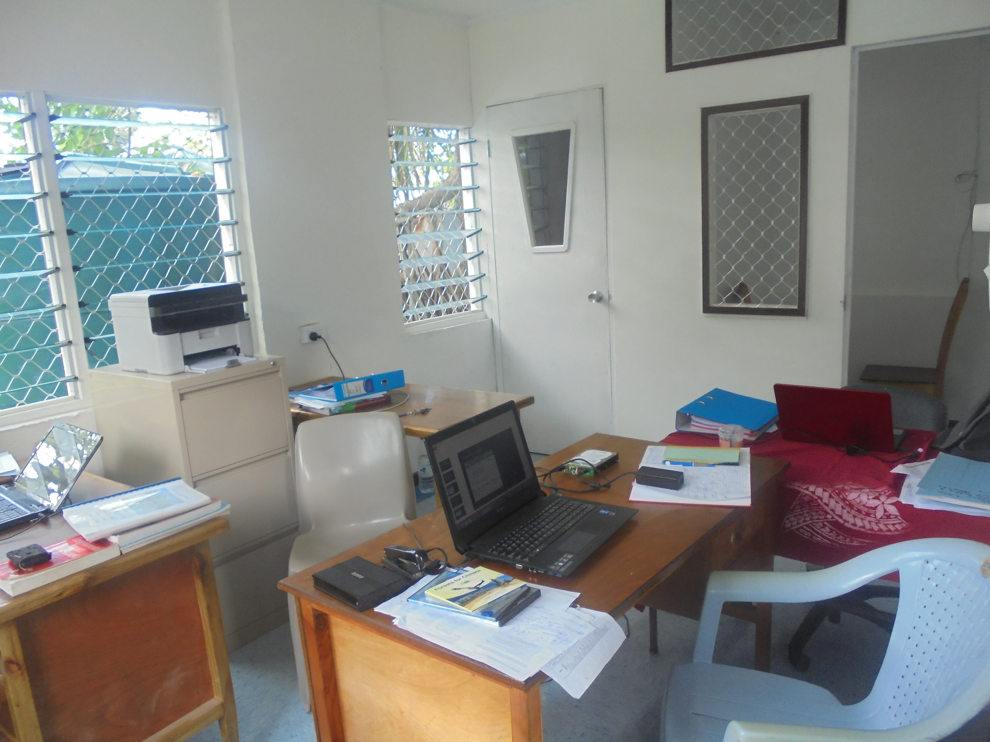

Annex 2
Recommendations
Based on the assessments above, the following are a number of recommendations that the Team believe will enable ECD to successfully fulfil its vision of having a sustainable Environmental Management Information system in place.
1. New Server for EMIS
A new server should be procured specifically for EMIS with the following minimum specification:
• Server brand (e.g Dell or HP)
• 2.5Ghz Quad Core Processor
• 16GB RAM
• 4 x 600GB 10K hard drives configured in RAID 10
2. Network Switch and Cabling
• A new gigabit network switch should be procured to provide faster speeds (up to 1gbps)
to all staff computers.
• New CAT6 network cables should be installed all around the Division office so that staff may be able to use the cable at most locations in the Ministry. This will require installing 2 wall mount sockets per computer in all rooms of the Division to provide redundancy in case of unforeseen problems with some cables.
3. Access Points
• There’s a need to procure for more powerful Access Points that will enable to reach all the ECD rooms from one central location. This will replace any wireless extending devices currently in place. Recommended APs are Linksys, Ubiquiti, and TP-Link.
• The access points should support the newest wireless standards such as 802.11n and 802.11ac
4. Antivirus Software
• All computers should have a fully licensed antivirus software to protect the users from security threats that may affect their documents and files especially those stored on a centralised location. It only takes one infected computer to infect or render the data or files useless on the centralised data repository especially with the advent of ransomeware (viruses that encrypt data on a computer and ask for a fee to unlock it)
• Recommended anti virus softwares include Bitdefender, Kaspersky, Avira, Eset Endpoint and Avast.
5. Uninterruptible Power Supply
• An online UPS is needed to support the operation of EMIS. An online UPS is one that provides extra protection from power surges as well as power outages as it runs on battery all the time. The minimum rating of 1000VA is recommended for the server specified above however the bigger the better.
6. On-site/Off—site Backup System
• This can be in the form of a Network Attached Storage (NAS) that will store all data stored on the data repository as well as the EMIS. A NAS system with a minimum capacity of 4TB (2 x 4TB configured in RAID 1) is sufficient for all ECD data and future needs. This will be setup in the MELAD Headquarter office so that the backup can act as an off-site one but at the same time close enough to ECD in case of a need to quickly restore any required data.
7. New Internet Connection
• The current internet connection is sufficient for ECD staff internet use only so if there are plans to have EMIS accessible over the Internet, a new Internet connection will need to be setup so that ECD staff internet traffic will not have any impacts on the accessibility of the EMIS from the Internet and visa versa.
• An ADSL modem (or similar technology) with minimum speed of 512/256kbps should be configured solely for EMIS however speeds in excess of 1gbps/512kbps would make EMIS more responsive from outside the ECD network. Access to EMIS from within ECD, ie from staff is not affected but this as they will be accessing EMIS via the local network.
8. Firewall Software
• A dedicated firewall software will be required if EMIS will be accessible from the Internet so that it will be more difficult for malicious users (hackers) to gain access into the ECD network infrastructure and consume or corrupt data
9. Current Infrastructure and Data storage practice
• The current server is more than capable to act as a data repository for the data collected for EMIS
• A new shared drive should be created to store data collected for EMIS
• Backup should be carried on the file server on a more regular basis (i.e weekly) and two copies of these on two different storage media is better than one.
• Current Access databases should be stored on the server and one copy only should be kept
• All data and files on staff computers should be copied to the file server so that data can be securely stored and backups can be made on all ECD data and files.
• A licensed antivirus should be introduced to the File Server just in case infected files happen to exist during files transfers and exchange between server and clients.
• A domain based infrastructure could improve the current level of user and group permissions on File and Printing services and other network resources of EMIS minimizing the security threats posed by unauthorized people happened to bypass Access points authentication security.

10. Proposed new Network Diagram
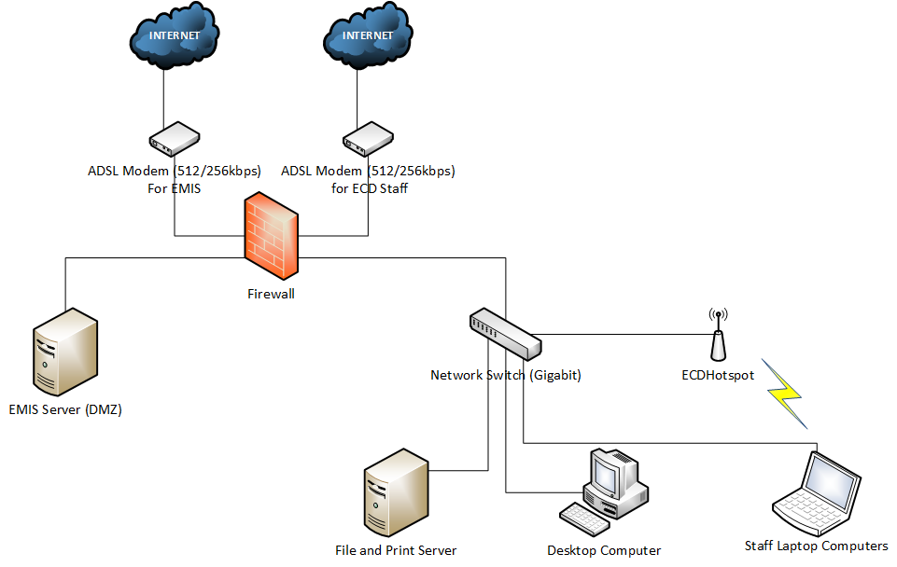
• The above proposed network setup requires EMIS Server to be configured in a DMZ (Demilitarized Zone) which enables for a more secure public facing service that does not expose the local network to the Internet
With the above findings, there is a need to upgrade the current network of ECD in terms of hardware and software technologies including the increase of internet bandwidth to support the development of EMIS.

